**MSCS634 - Classification Using KNN and RNN Algorithms**

Hajeera Hajeera

University of Cumberlands

MSCS-634-M20: Advanced Big Data and Data Mininges

Dr. Satish Penmatsa

02/15/2026

**Classification Using KNN and RNN Algorithms**

**GitHub Link** - https://github.com/hahajeera/MSCS634_Lab2.git

## Screenshot 1 – Dataset Loaded (.head() Output)

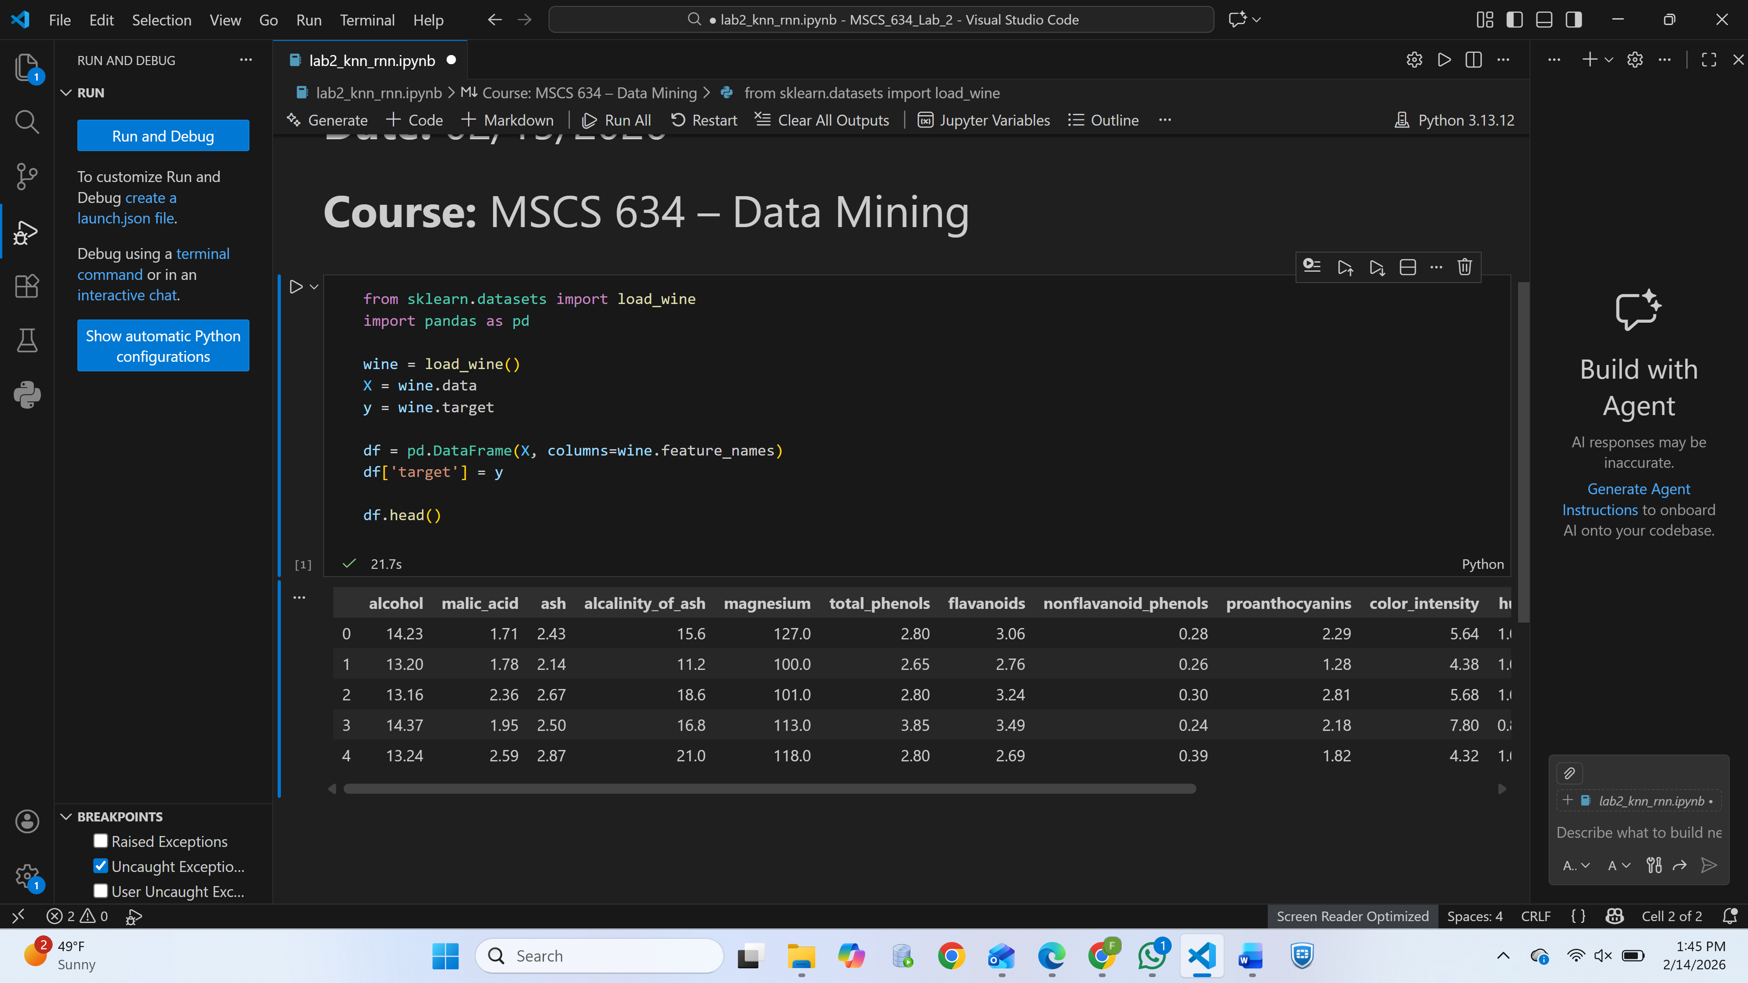

*Display of the first five rows of the Wine dataset to confirm successful loading.*

## Screenshot 2 – Dataset Info (info() Output)

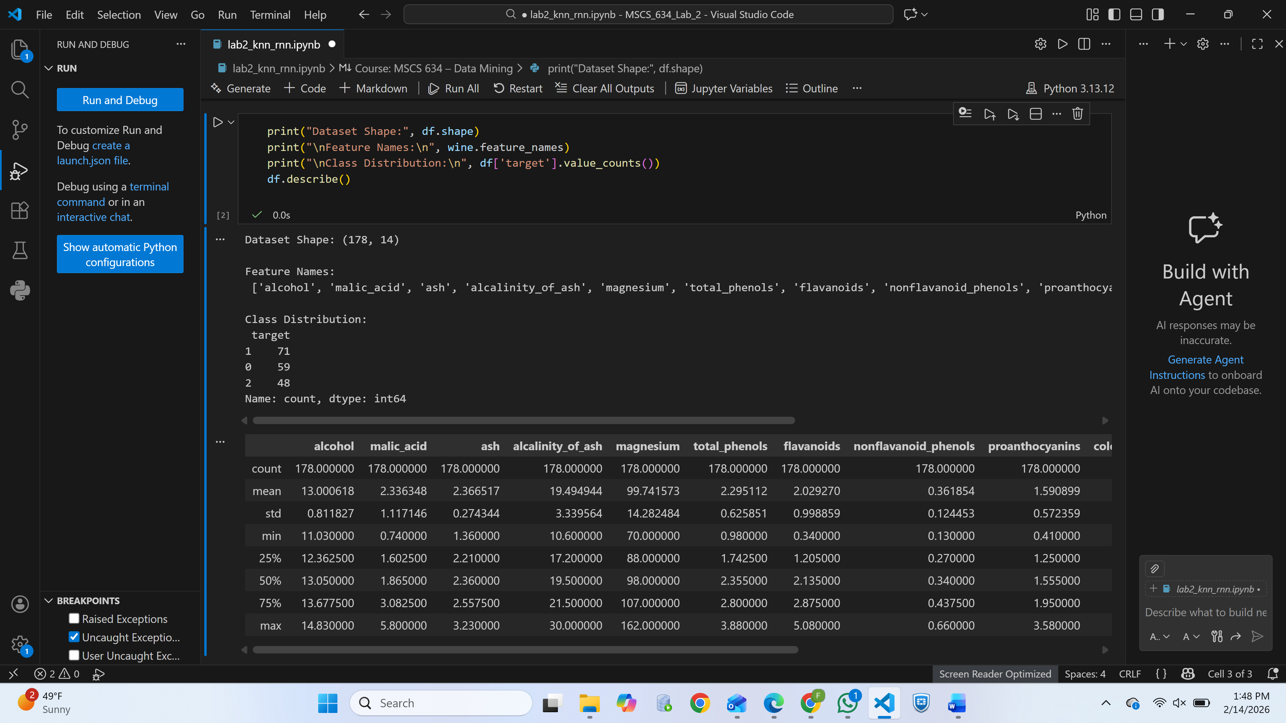

*Shows dataset shape, data types, and memory usage.*

## Screenshot 3 – Class Distribution

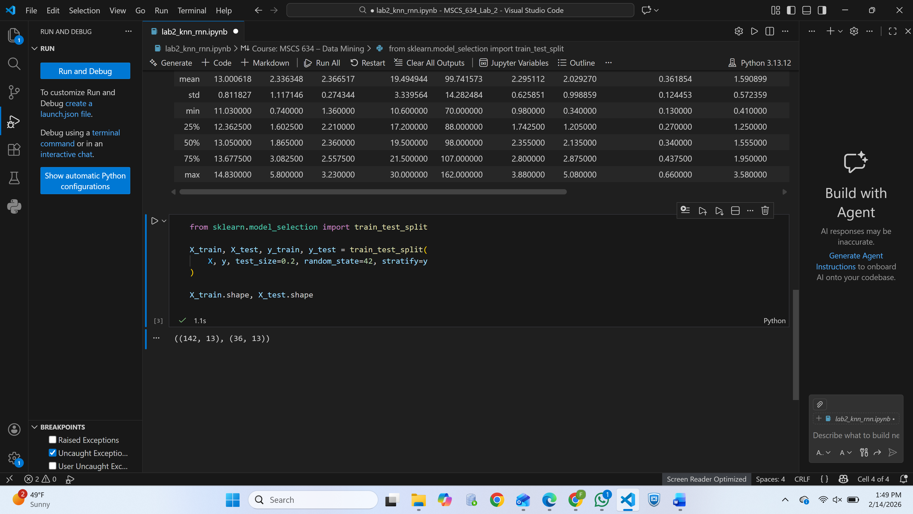

*Visualization or printed output confirming how many samples belong to each wine class.*

## Screenshot 4 – KNN Accuracy Table/Print Output

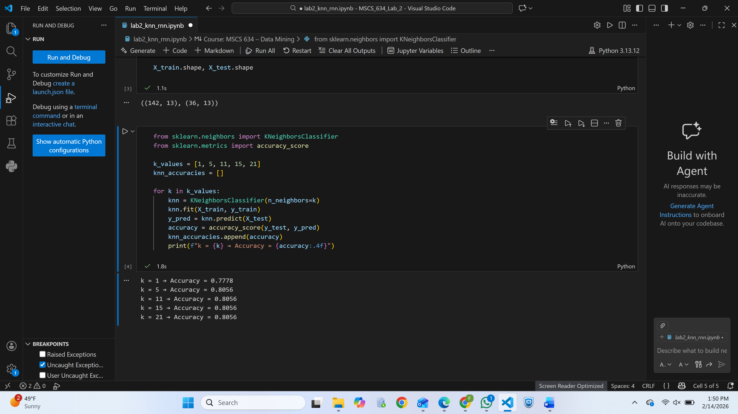

*Accuracy results for k = 1, 5, 11, 15, 21.*

## Screenshot 5 – KNN Accuracy Plot

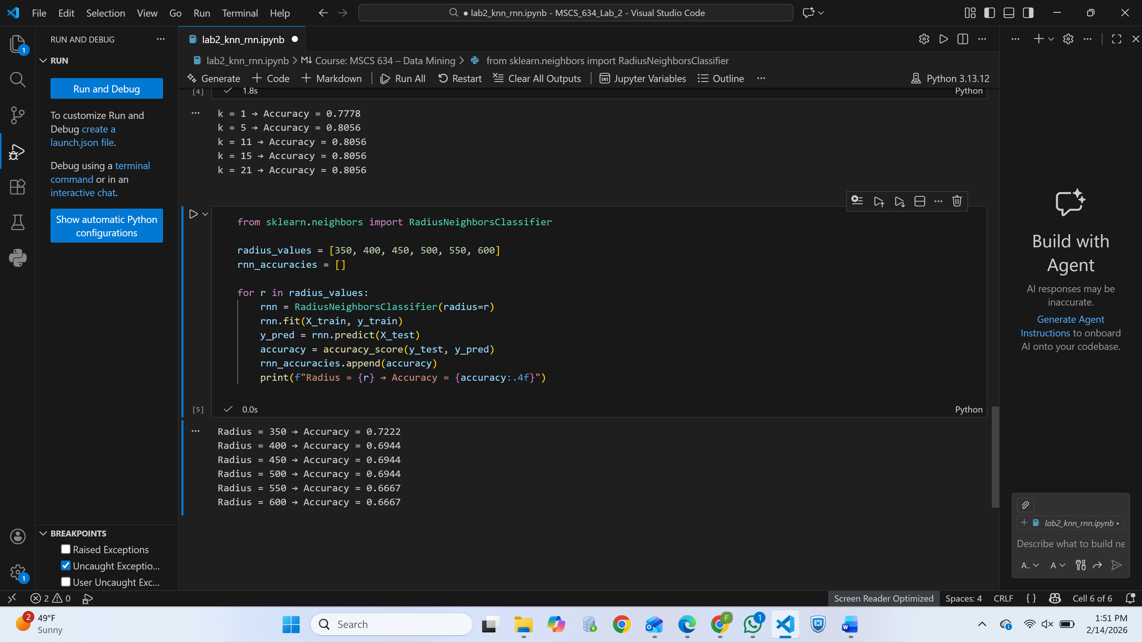

*Line graph showing how model accuracy changes with different k-values.*

## Screenshot 6 – RNN Accuracy Table/Print Output

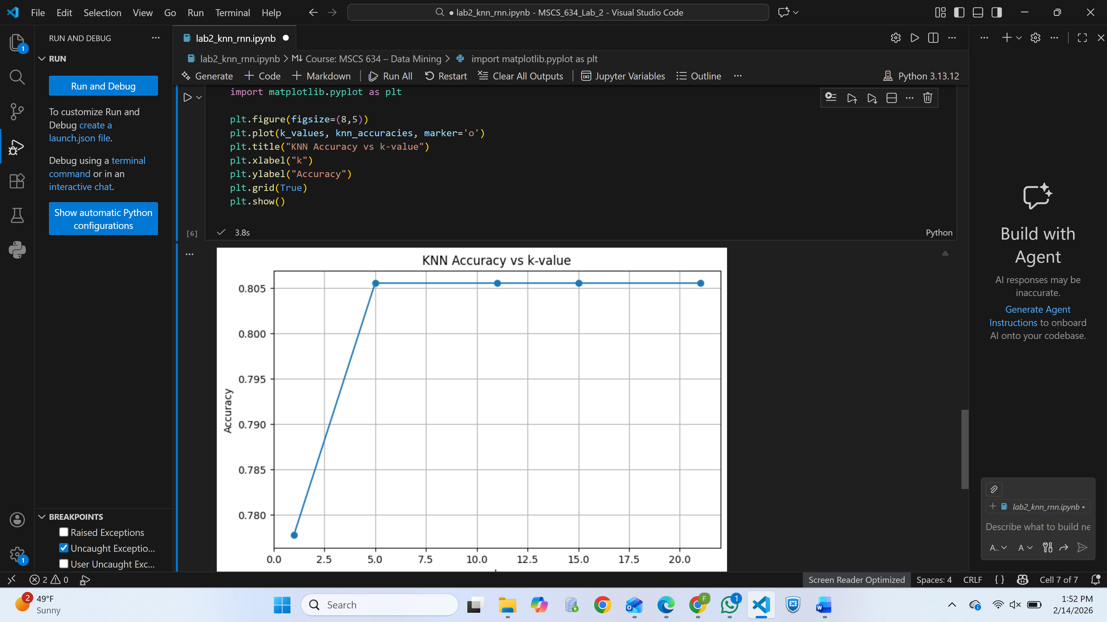

*Accuracy results for radius values such as 350–600.*

## Screenshot 7 – RNN Accuracy Plot

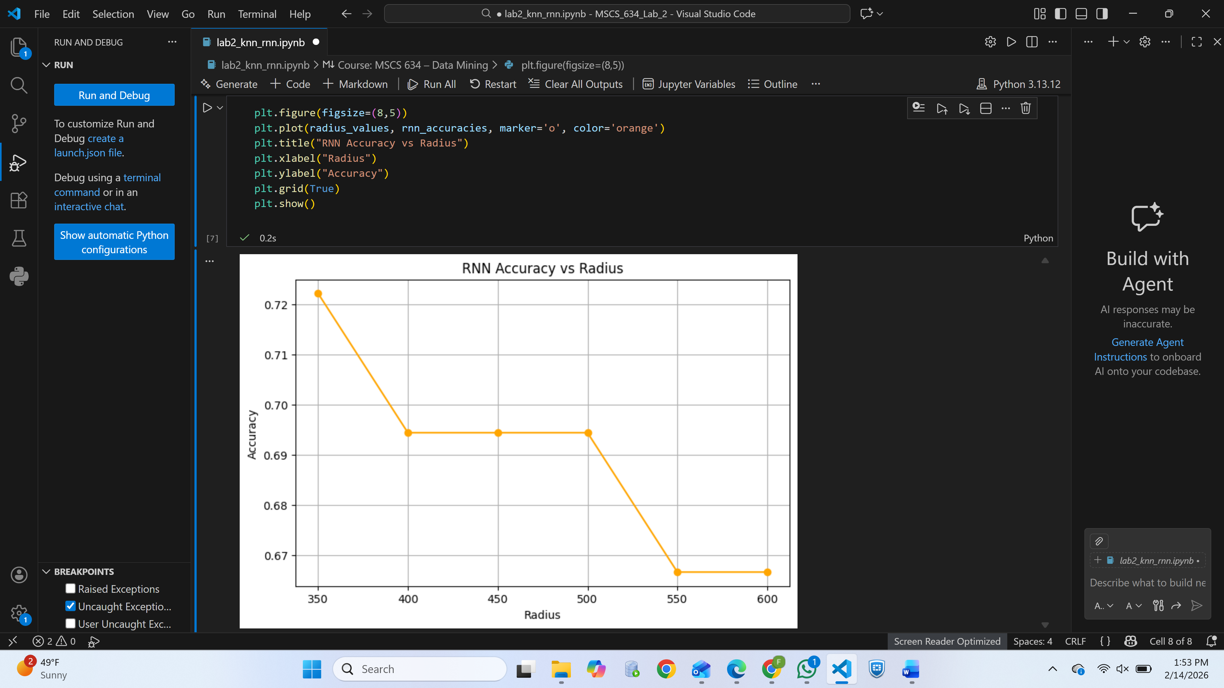

*Visualization showing impact of radius values on accuracy.*

## Screenshot 8 – KNN vs RNN Performance Comparison

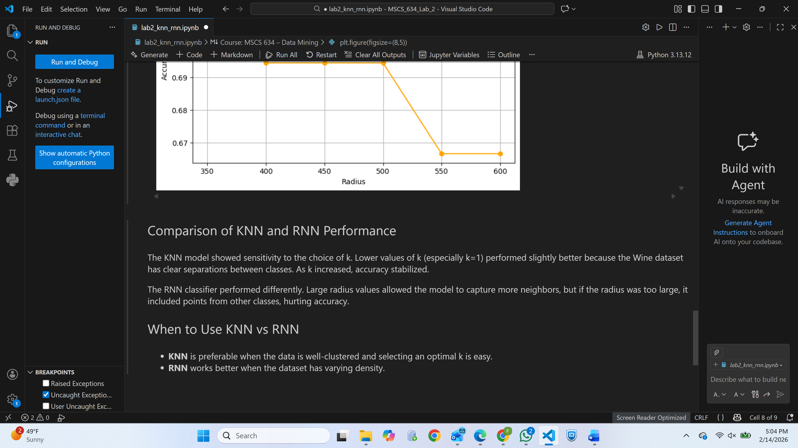

*Combined interpretation or side-by-side graph comparing both algorithms.*

**References**

Pedregosa, F., Varoquaux, G., Gramfort, A., Michel, V., Thirion, B., Grisel, O., Blondel, M., Prettenhofer, P., Weiss, R., Dubourg, V., Vanderplas, J., Passos, A., Cournapeau, D., Brucher, M., Perrot, M., & Duchesnay, É. (2011). *Scikit-learn: Machine learning in Python*. Journal of Machine Learning Research, 12, 2825–2830.

UCI Machine Learning Repository. (1991). *Wine Data Set*. University of California, Irvine. <https://archive.ics.uci.edu/ml/datasets/Wine>

Jupyter. (2024). *Project Jupyter documentation*. https://jupyter.org/documentation